POUNDBURY: A DIFFERENT SET OF QUESTIONS

Jenny Quillien
Sustasis Foundation
October 2023

Announcement to the Reader:
What follows is a confession and an informal chronicling of some clumsy sleuthing on my part as I tried to come to grips with the making of livable cities. A heuristic insight was eventually obtained.

The Scene:
The October 2023 International Conference on Making Cities Livable was arranged so as to take place in both Dorchester, an old town of southern England with its long history, ancient stones, busy High Street, and also in the adjoining new town of Poundbury, pet project of then Prince Charles with his abiding interest in questions architectural and fondness for 18th century forms. My proposal aimed to take advantage of the possibility of dual walkabouts to compare traditional generative structures grown over time through the touch of many hands (illustrated by Dorchester) versus fabricated structures that result from modern building technologies and centralized planning (Poundbury).

Preparing for a talk is usually a good idea. Getting the feel of a place is best done solo. Therefore, a couple of days sojourn seemed in order. I traveled to Dorset, walked and walked, sat in the pub in Poundbury, sat in a pub in Dorchester, watched, and listened. Sometimes I asked for directions I didn’t need just to see if I could strike up conversations. Nothing scientific, mind you. No interviews based on proper sampling; no statistically significant numbers, but enough for my purposes. Comments were not all over the map. Some were mild, “Oh. Poundbury,” replied one Dorchester shopkeeper, “Well, it does bring in a bit of traffic and that’s good for business.” Many were non-verbal. One Dorchester bartender rolled his eyes with, “A different sort of people over there.” Not a single Dorchester person had anything genuinely positive to say about Poundbury and the bulk of comments had a disturbing poignancy about them. Locals were dismissive of this ‘’new town” in a way that conveyed both hurt and anger. This surprised me, confounded me, really. Why this contempt for Poundbury? Why? Poundbury is not a sprawl of ugliness produced by some seedy greedy speculator. Poundbury was built (and continues to be built) with good intentions, talent, a wish to build aesthetically pleasing buildings congruent with regional history, a concern for social issues, social housing, economics supportive of local suppliers and resources, the earth, ecology. The negativity seemed out of keeping and became, as it were, the elephant in my mind. I had no idea what to do with it, so I ignored it. As we tend to do with uncomfortable elephants, I just swept it under the rug and proceeded with my preparation. That was poor Sherlocking on my part.

The Talk: Alexandrian Mistakes

A synopsis of the presentation (which ignored the elephant) goes like this: I start by accepting as a given Jane Jacobs’ crisp and concise scolding of urban planners for misunderstanding the nature of their task.¹ Urban design is not about simple problems involving few variables, nor does it lend itself to statistical thinking. Urban design problems lie in that middle ground of a dozen or two dozen variables which interact in complex ways. In other words, urban planning is a problem of organized complexity and it’s a slippery business: if we miss a variable, we will miss out on the livable liveliness we seek. Jacobs suggests that our sister field of investigation is biology where questions, say about growth or decay, are also questions of organized complexity. Researchers in organized complexity should proceed from the particular to the general, keeping an eye for unaverage clues which might reveal underlying phenomena.

Next came Christopher Alexander who had couched his similar understanding a bit differently. “The primary way in which complexity of structure reveals itself is in the internal density of significant relationships which exist when adaptation occurs successfully.” In these successful cases “each element is created in such a way as to avoid its possible mistakes. It does this by creating meaningful relationships in every direction.” ² In other words, livability and liveliness would be descriptors of urban fabrics with a high density of mistake-free relationships. This formulation enriches Jane Jacobs’ scolding in a very practical way. It provides a real handle for both making and evaluating.
The Alexandrian readership knows that the concept of ‘mistake’ has always loomed large in his work. Back in his Ph.D. thesis, Notes on a Synthesis of Form, the continual and timely correction of ‘misfits’ was key to the health and evolution of the organic and complex urban fabric of the traditional Indian town that he was studying. The feedback loops, i.e., the power to correct, lay with the locals who knew the variables intimately and could directly carry out the most appropriate fix. In later writings, pattern languages are shown to evolve similarly through the constant honing, elimination, and addition of individual patterns. In his magnum opus, The Nature of Order, virtually all of the second volume is a reflection on generative structures and processes which afford us a higher density of internal relationships and fewer mistakes. They do this by ‘growing’ in place, from the inside out, from the everyday cultural practices of dwelling. Since growth is sequenced over time, stage by stage and participation is wide and deep, misfits can be recognized and corrected in situ and almost on the fly. The generative approach stays close to innate human capability: at any point in time there will be a manageable number of relationships to respect, hence mistakes can be avoided or remedied. Dorchester, with its long history, has grown in such an indigenous way.
A mistake is a failed relationship between parts of a system. Image used as the cover of Don Norman’s Design of Everyday Things. Source: Google images.

Alexander places generative structures in opposition to current fabricated structures which result from modern practices. Essentially extrinsic, fabricated structures are based on a plan, built top down not bottom up, with centralized control over technology and finances. Time is money so building fast is good, plans are financial control mechanisms and therefore anathema to feedback and change. Alexander stridently denies the possibility of livability and life coming from fabricated structures. Alexander’s firmly camped position of you-can’t-get-there-from-here is compelling but to this question we must return because, like it or not, here (modernity) is where we are.

For the presentation, I picked a couple of ‘mistake’ objects from the Poundbury hotel where I stayed. Then, a few comments from Poundbury residents were related. For example, complaints abound about the parking garages, deemed too difficult to enter or exit and too small for the ever-fatter automobiles. So now empty parking mews take up valuable urban space while the cars fill up the community squares and roads—a visual blight.

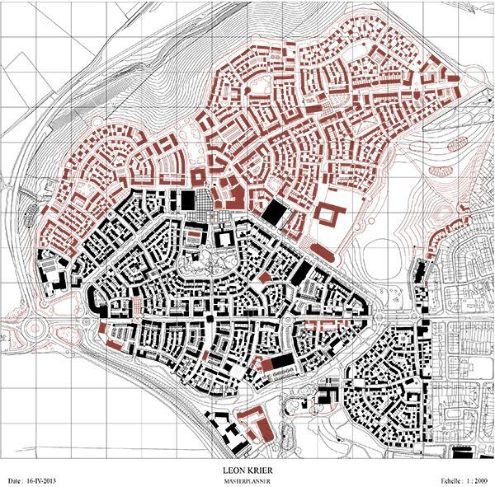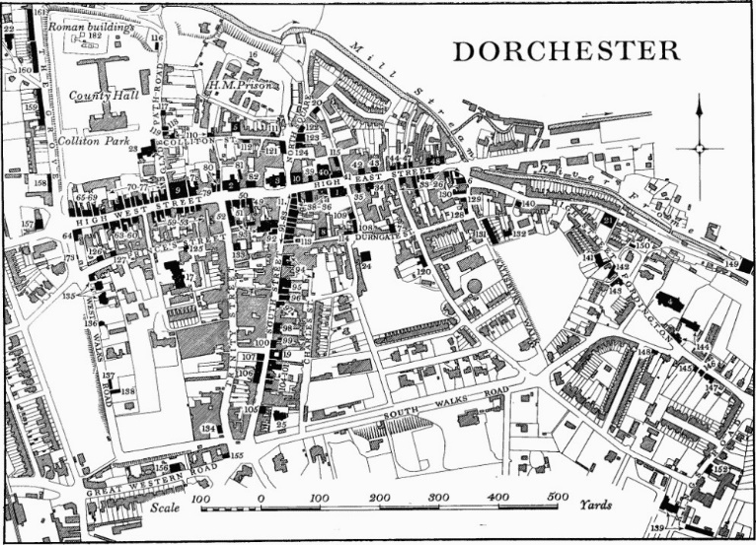
Plan of Dorchester. A layering of centuries hence a rich internal density of relationships. Source: Wikipedia.

Masterplan of Poundbury by Leon Krier. Best in class but still shallow. Laid out all in one go. Source: Wikipedia.
We looked at maps of both Dorchester and Poundbury. Participants were invited to evaluate two features key to generated structures: centers and boundaries. Dorchester’s center brims over with a variety and depth of encounters: the 15th century church garden with its yew tree (reminding us of death and immortality) cohabits with the 1850 Corn Exchange and the usual suspects of today—Boots, Lloyds Bank, the dine-in or take-out Indian eatery, the used book handler on the sidewalk. There are, for sure, blemishes and scratches, and signs of wear and tear, but you can get your car fixed, get a document on your thumb drive printed, and, of course, get a glass of ale. In Poundbury, to use Gertrude Stein’s famous quip, there is no there, there. There are a few scattered shops, one for bridal gowns, another for gourmet chocolate, and another for expensive wines, a dentist, a chiropractor: the whole place empty of people. Boundaries, like picture frames, should both separate and connect, and can be places of activity in their own right. Poundbury boundaries fail to connect, making for isolation on the east side and annoyed neighbors on the west, particularly along Whitfield Road. Would these mistakes have been made in a generated structure? Certainly not centers since generated structures invariably grow from initial centers which are intensified over time.

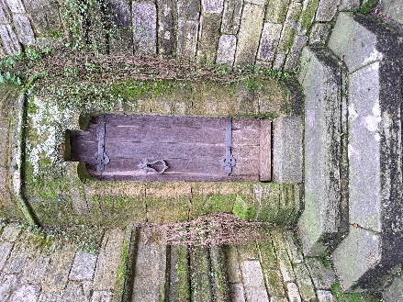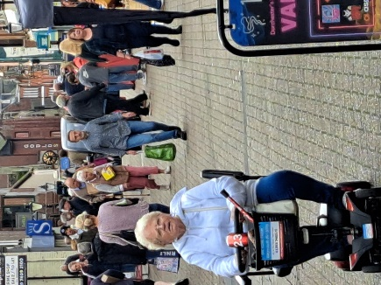
Center Dorchester. Shopping street with the pleasant hustle and bustle of a regional town. Photo by Author
Center Dorchester. My favorite spot. About 20 paces from the shopping street in the photo to the right. Photo by Author

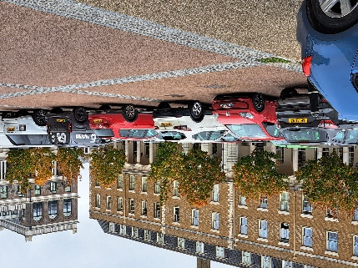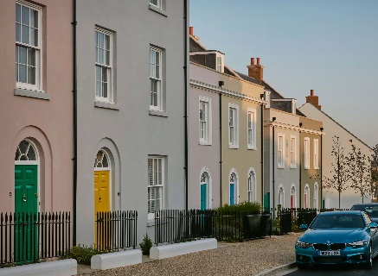
Poundbury streetscape. Photo by Author
Poundbury. Queen Mother Square. The building with columns houses the Waitrose grocery. Photo by Author

But back to the elephant in my mind: Mistakes and all, Poundbury deserves respect: we have here a bold innovative endeavor that shakes up thinking about housing and urban development: walkability, mixed use, one job per home, 35% low-cost housing, renewable energy, support for independent artists. So, again, why the negativity?

A First Clue:
Sometimes (another confession) when I can’t solve a problem, Sister Serendipity arrives on gossamer wings. Just two days before the conference, sent my way was a 1985 reflection by an Australian architect by the name of Kimberly Dovey.³ I am indebted. The read was a lock and key experience. His topic? Fakery.

Fakery. The antagonisms about Poundbury all point in that direction: imitation, fake, phoney, counterfeit, make-believe, not real. They were expressed by a wide range of people, from professional architects to the cleaning staff at the Poundbury hotel. But this all requires a bit of unpacking.

First of all, fakery does not necessarily lead to contempt. We all quite happily suspend belief at the movies and gasp as the protagonist is thrown through a window which we know full well to be sugar glass. Fakery surrounds us. Take the hearth. A good fire warms, gathers us round, gives context to our conversation. A lot comes with it: put on a jacket and go outside to get more wood, maybe chop wood, sharpen Grandpa’s old axe. We appreciate the hearth and engage with it. But a fire can be smokey and the ashes have to be swept up, so it gets replaced by a gas fed flame and metal logs. No crackle and pop, no aroma, no warmth. Maybe we’re disappointed. We stop by a pub where a big computer screen plays a video of flickering flames. We groan at that nonsense. But in all cases, we know exactly what the score is. Fakery it may be, but it doesn’t breed much contempt. Emotions such as contempt are expensive: they take a lot of energy out of us. The obviously fake fire isn’t worth it and the film is good fun.

Dovey’s starter example is the old fashion wooden shutter which one pulls in at night. The shutters embody all kinds of meaningful relationships: with that which is shut out (the dark, the cold, the dangers) and that which is shut in (supper, bedtime stories, conviviality), with the rhythms of day and night, with the seasons and the storms, and the dweller who opens and shuts. Many houses now have decorative panels at the side of the windows. They aren’t meant to be functional—they might not even cover the window if they could close, which they don’t. These decorations don’t upset anybody because it’s obvious. But, says Dovey, what about shutters that actually look like the old wooden ones and it’s only when you attempt to engage with them that you discover the sham? Now, that’s a fakery that aims to replicate environmental meaning by manipulating appearances and if the fakery does it well enough to fool you, and then you find out, well, then, you are likely to be annoyed.
So, it is only good i.e., well done fakery which is under investigation. I review the particulars, the unaverage clues, of my hotel stay in Poundbury. I had experienced and photographed two mistakes. One was of an unmovable piece of plexiglass which separated the bathtub from the sink: you actually could not run a bath. To reach the spigots you had to climb into the bathtub. The second was of the cheery colored breakfast coffee cups. The container part of the cup was far heavier than the handle could gracefully support and when filled with liquid required real attention. I watched as people spilled coffee into their laps or lunged with a last second effort to bring in their other hand to keep the cup from tipping over. At breakfast I had request a café latte. Denied. It would have to be charged separately on a bar tab. The second morning another waitress was willing to make me one. ”Nobody will know the difference” she said with a grin. Hmmm? I had thought. Jane Jacobs’ unaverage clues? Where was I? Separate bar tab? Any local hotel owner with direct control would have remedied those two misfits. Could I be in a chain? That turned out to be the case—a chain of 250 establishments. It was posing in Poundbury as a local business and I had been duped. Nobody likes to be duped. Antique furnishings and ever so cute English gewgaws were the forged signature of authenticity but chain-ness had given itself away through bureaucratic procedures and the way the staff abstained from engaging with their surrounds and each other. I had allowed myself to be lulled by pretenses, and, then, the realization of the truth had left me feeling a bit deflated. I would have preferred an open declaration of chain-hood. Is this experience trivial? What is not trivial is Dovey’s point: Authenticity is about process and meaningful relationships, not forms.
She and I know how to hold the cup. Website photo from the Duchess of Cornwall Inn which belongs to the Hall and Woodhouse chain.

Just as a chain hotel (whatever its garb) is a different animal than a local establishment, Poundbury (whatever its garb) is not a town based on civic processes and citizen relationships. Poundbury is a modern real estate venture—unusual, cutting edge, green, fascinating—but a real estate venture run by the Duchy of Cornwall. In the conference presentations by the Duchy, number one on their list of critical success factors was single ownership of the land. The covenant is the main control tool. Anyone who buys into Poundbury also buys into the covenants and the authority structures. The expression benign dictatorship was wryly used by one Duchy staff member: these highly skilled stewards, with their eye steady on the till, are the arbitrators on change and adaptation—how, for one example given, to maintain the desired look and feel of Poundbury and yet possibly yield to the request of charging stations for electric vehicles. Frankly, (confession again) Poundbury demonstrates that we can do a lot worse than benign dictatorship with sensible covenants—as long as we’re clear on where we are and what’s going on.

A Second Clue
Isn’t it amazing (at least for me, I confess (again)) how a concept we haven’t thought about in years and years just comes strolling back to the center of our minds and waves hello there! ‘Twas the opening plenary panel discussion of senior architects and planners. “We have been entrusted with a duty,” droned one voice. “But should we allow participation?” pondered another. The word control rolled off the tongues. Suddenly, waving hello there! was that old pop psychology notion of transactional analysis and Eric Berne’s 1964 best seller, The Games People Play. According to transactional analysis, we position ourselves in our encounters as child, adult, or parent. Here, in front of the audience, was a cabal of leading urban professionals exchanging parent-to-parent thoughts on how to handle their citizens aka children. Transactional analysis tells us that unfortunate things happen If we come to an encounter seeing ourselves as an adult, expecting an adult-to-adult exchange, and are met by a parent: then we are diminished, frustrated, and annoyed.

A later session was dedicated to the topic of public participation. It was a rather boxy affair. Visuals were of flow charts with arrows indicating where stakeholder input should enter. The frame was explicitly medical: listen, examine, diagnose, and treat. The unquestioned larger paradigm of fabricated structure hung in the air. The first utterance of the first speaker: Sometimes it is better not to have any participation at all. If you raise expectations—people thinking that they will actually have a say in things—and then frustrate that expectation, well, things can backfire and be far worse than having no participation at all. Tricks of the trade were shared: “Take on the trouble-maker (there is always one) first thing.” For those with a theatrical bent: “Take your head in your hands and look concerned and overwhelmed. It can get you some sympathy.” General assessments were shared: “community input always, again and again, boils down to three concerns: property values, security, and privacy.” At the break I queried the representative of the Duchy as to the history of Poundbury. The answer: “Well, that was before my time, 30 years ago, and the Duchy doesn’t talk much about community participation at Poundbury. I know there was one attempt at a charrette but it turned out to be tricky.”

In another session, framed by the contrasting paradigm of generative structures, practitioners and teachers also spoke of participation. Before any planning happens, there is an invitation to be vulnerable. Vulnerable (think about that!) and tenderly allow others to be vulnerable. The invitation is to go within and then share one’s heart’s desire about a place-to-be. Contributions might be something along these lines: “What I would really like is a quiet place to walk between the classes I teach so that I can collect myself and my thoughts.” Or, from that child within, “I’d love a porch with a swing and a trellised rose bush like Grandma had.” The architect/planner’s role is that of midwife or translator of these dreams, perhaps guiding a project pattern language that will, in turn, guide actual making—but it is all from the heart. A hallmark of generative processes is the surprising unpredictability of outcome: this is a universe away from fabricated structures where predictability is ground zero.

In his inquiry into fakery, Dovey is explicitly Heideggerian. He uses the Heideggerian term Zuhandenheit, which literally means a readiness-to-hand, to foreground action-based involvement. He is emphasizing tools (be it a hammer or a language) and their implementation. If we take an axe in our hand to chop firewood, the axe becomes an extension of our arm. We learn about wood and whether it is soft or hard, slow burning or fast. As we chop wood we also learn about ourselves, what we can or cannot accomplish. We are doing the same if we use language to work through a problem, negotiate, or partake in a charette. In other words, it is through involvement that the world discloses itself to us and we disclose ourselves to the world: this is fundamental to our being and sense of self, both as individuals and as communities. Therefore, Zuhandenheit is the term for highlighting interaction, meaningful relationships and processes. The term Vorhandenheit corresponds to passivity. Objects are simply there for contemplation but not interaction. A zoo, for example does not involve us in the same way as would paddling a canoe through the Amazon River basin. Poundbury, it can be argued, is set before us to passively contemplate. It stands as a replica of an idealized 18th century Dorset town. Many of the people I listened to were unenthusiastic about the wholesale copying of a style from bygone days. Many of them viewed it as fake, a bit like a movie set is fake. Somehow, I don’t think that was the crux of the matter. My guess is that they resented the muddling of Vorhandenheit with pretenses of adult-to-adult Zuhandenheit.

In summary, the fakery being talked about here is clever fakery that takes itself seriously and willfully attempts to create shared meaning through a prop that was not born of meaningful relationships. When the fakery is sophisticated, as is Poundbury (or participation-in-order-to-placate), it breeds distrust and contempt. To disregard this contempt is more than a mistake; it is a meta miss-take; and, following the advice of Jane Jacobs, we should now move our thinking from the particular (this case) to the general (good cities). What could possibly be more germane to the making of livable cities than honest interaction, which remains the foundation of social life. Without this kind of honesty, the rejection of the counterfeit will outweigh positive consideration of other factors. This is what I propose to call, as shorthand, the Poundbury effect.
Back to the Future
Returning now to the conundrum which plagues at least some urban planners.

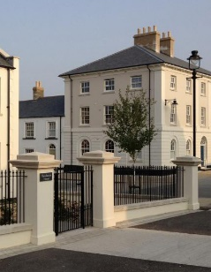
There is increasing agreement that fabricated structures cannot yield life or livability—as well built as Poundbury is, its physical structures are rather lifeless. It is clear that we cannot return to the past and give ourselves centuries to build a town or a cathedral. It’s also clear that we have to figure out some way to get beyond the Alexandrian declaration of impasse. As John Habraken in The Structure of the Ordinary puts it: The idea that a living environment can be invented is outmoded: environment must be cultivated . . .while remaining faithful to the relations of their constituent parts.
Poundbury. Experienced by many as flat, like a movie set. Photo by author.

Two approaches seem promising.
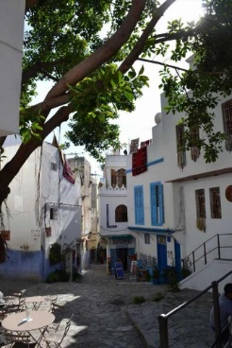
One approach is to take inspiration from the investigation of building codes of medieval Muslim cities of the Mediterranean.⁴ These codes are quite abstract: nothing like our concrete and mechanistic rules of 10-foot setbacks and the like. The medieval codes render explicit the meaningful and significant relationships that must be respected. The relationships are the code. This is in keeping with our discussion of fakery: it is authentic relationships which lead to authentic form. A few examples: Existing buildings have priority over new ones. A new construction must respect the views and privacy afforded by the existing structures. How this is to be done is left to those involved. A walkabout through these town gives great delight in the creative range of shapes, rhythms of off-set doors and windows, semi-hidden entrances, adaptations to circumstance. The solutions are never the same but always coherent. Or, for a second example, all new houses must be in earshot of the call to prayer. When this becomes problematic, it is time to build another mosque. And, again, the walkabout gives delight in the larger scale fabric and the quilted rhythms of secular and sacred. Why not consider what this approach might bring?
Kasbah in Algiers. Source: Google images.

The second approach, also in keeping with our discussion of fakery, rethinks how to limit the role of centralized planning and then turn things over to the many hands of local inhabitants. To quote from a recent paper along these lines:

It is not planning per se that is the problem, but knowing what needs and can be planned, and what needs to be allowed to evolve. Thus, planning’s role can be redefined as creating the structures, both physical and regulatory, that will allow informal participation to occur freely and create life, beauty and wholeness in the built environment.⁵

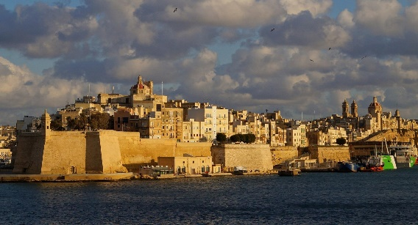
This is also not a brand-new idea. In 1566, on the island of Malta, Jean de Valetta, the crusaders’ Grand Master Engineer, ordered up a new town, which is now called Valletta. Centralized planning for the construction of ramparts for town and port as well as accommodations for water and sewage. A few major throughfares were laid out between city gates. After that, further infill construction was turned over to the community along with some general instructions. For example, those who took corner lots were responsible for some sort of ornamentation. What kind of ornamentation was not specified. Valleta is a magnificent town, deeply alive. The shapes and complexities are, quite literally, the trace of time, a recording in stone of process and relationship.
Valleta, Malta. A planned and generated structure with life. Source: Google images.
The conference was excellent, and yet, and yet. There we were gathered explicitly to discuss the making of livable cities and these two paradigms, generated and fabricated, glided passed each other, proponents of each politely applauding presentations by the other, but with only the faintest inquiry into what was shared and what differed. The Poundbury effect was not discussed at all.

Notes
¹Jacobs, Jane. “The Kind of Problem a City Is,” from The Death and Life of Great American Cities, Random House, 1961, pp: 428-448.

²Alexander, Christopher. The Process of Creating Life. Volume Two of The Nature of Order, Center for Environmental Structure, 2002.

³Dovey, Kimberly. “The quest for authenticity and the replication of environmental meaning,” in Dwelling, Place and Environment: towards a phenomenology of person and world, editors David Seamon and Robert Mugerauer, Martinus Nijhoff Publishers, 1985.
⁴Hakim, Besim. Urban Rules and Processes: Historic Lessons for Practice, Emergent City Press, 2019.
⁵Porta, Sergio, Rofe, Y., Vidoli, M., “The Production of Cities: Christopher Alexander and the problem of System A at large scale.” Pursuit of Pattern Language for Societal Change (PURPLSOC), 2016.

